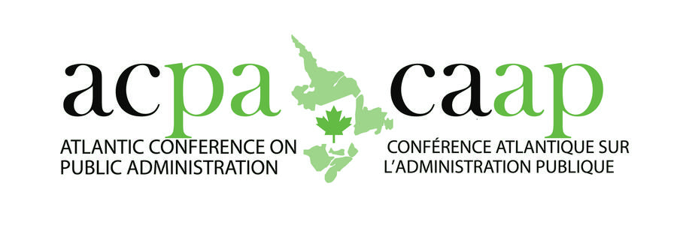

18th Annual Conference | January 25 and 26, 2018

CALL FOR PAPERS AND POSTERS

Interested graduate students are invited to submit papers for presentation at the 2018 Atlantic Conference on Public Administration, hosted by the Dalhousie University School of Public Administration. The conference, organized by Master of Public Administration candidates, is the leading Atlantic Canadian forum for students, academics, public servants, and business and public sector leaders to exchange ideas, disseminate best practices and discuss trends in public administration. The conference annually draws 200 delegates from eastern Canada, including a wide representation from federal, provincial, municipal and First Nation governments.

All students enrolled in a graduate studies program at an accredited university are eligible to apply, including part-time students studying at the Dalhousie University Centre for Advanced Management Education. Papers may be on any topic within the realm of public administration and public management, or may specifically address this year’s conference theme, “Stronger Together: Indigenous Reconciliation and Sustainable Growth in Atlantic Canada”, which will explore how reconciliation is taking shape in Atlantic Canada, its links to the sharing of Indigenous knowledge and understanding various ways of perceiving our world, and how indigenous and non-indigenous Atlantic Canadians can work collaboratively to build a sustainable future.

Those interested are invited to submit an abstract of no more than 300 words by Friday, December 22, 2017. The abstract must contain the applicant’s name(s) and student number(s), the paper title, summary of the paper including significant findings, relevance to theme (if applicable) and methodology. Abstracts are to be submitted in electronic format to Belinda Smith (Belinda.smith@dal.ca).

All abstracts will be adjudicated by an academic panel. Successful applicants will be invited either to deliver an oral presentation or to present a poster in a dedicated session at the conference. The David MacDonald Memorial Award and additional School of Public Administration alumni awards will be presented for leading papers and posters.
More details on the conference may be found at http://www.acpa-caap.com.

