2018-2019 WESTERN OGS/QEII
APPLICATION HANDBOOK

This document provides a visual presentation of Western’s online Ontario Graduate Scholarship (OGS) and QEII Graduate Scholarship in Science and Technology (QEII‐GSST) Application.

Top of Every Page ..............................................................................................1
Introduction ..............................................................................................………2
Application Progress.......................................................................................... 5
Academic History .............................................................................................. 6
Proposal ............................................................................................................ 8
Referees.......................................................................................................…….9
Finalization.......................................................................................................12

As you progress in the application will be able to save and continue the application at any time. Once your referees have submitted their references you will be able to ‘finalize and submit’ the application. After you have ‘finalized and submitted’ the application you will no longer be able to update or modify the application. Your application must be 'finalized and submitted' by the application deadline in order to be considered.

Top of Every Page

The top of every application webpage shows your name and student number.

If you want to log out at any time, you can do so by clicking on the “Log Out” link. However, before you exit, save your work (or it may be lost). There are “Save” buttons at the bottom of every section.

Below your name, there are tabs that will take you to the different pages of your application:

- Intro
- Progress
- Academic History
- Proposal
- Referees

You can go to the different pages by clicking on these tabs.

Introduction

This information service appears to the applicant automatically on first access, then by selecting the “Intro” tab in the top menu on subsequent visits.

The Intro page gives a brief overview of the OGS Program, lays out the eligibility conditions that the applicant must satisfy in order to proceed, and lists the components that the applicant must complete in order to finalize and submit the application.

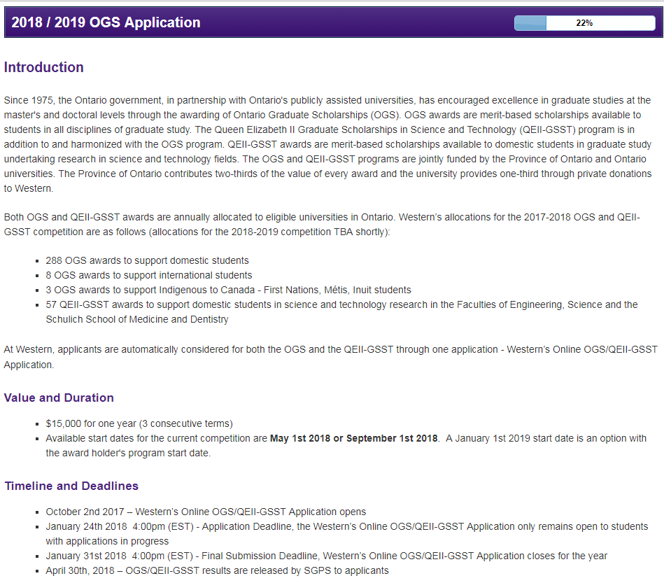

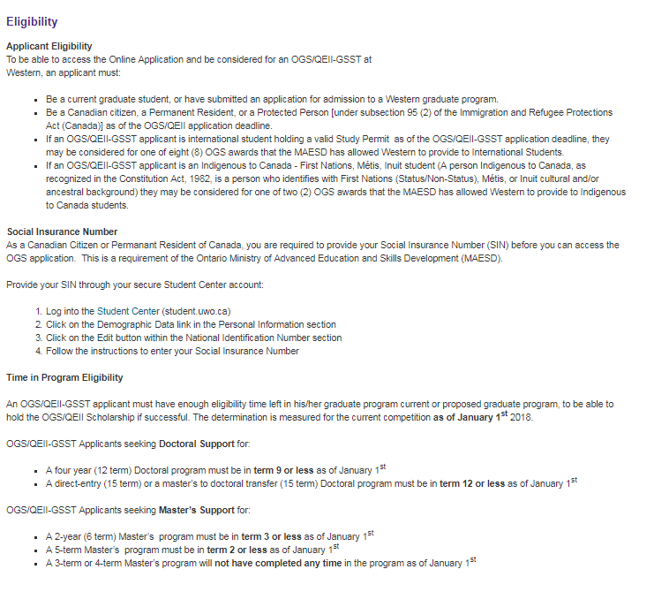

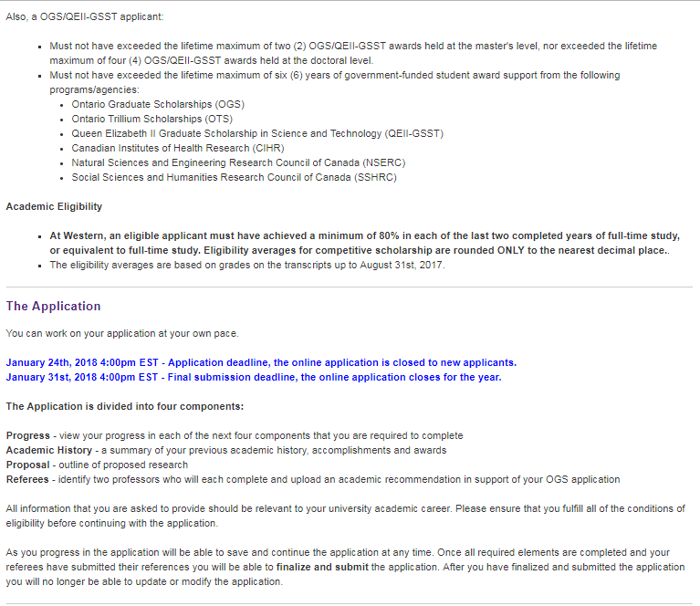

Application Progress

After first access, this page becomes the applicant’s homepage, headlined with a visual reminder of how far along in the process the applicant currently is, and identifies which components of the application still need to be completed.
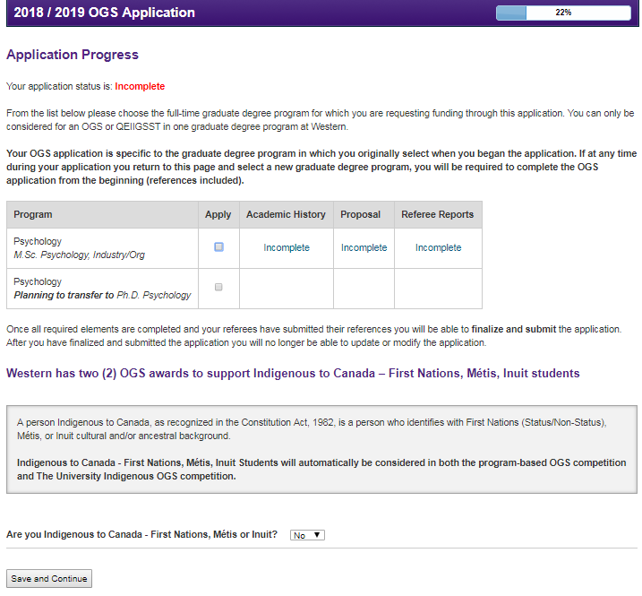

Academic History

This component offers fields in which the applicant may provide details of their post‐secondary record that are relevant to the application in four (4) distinct sections:

- Academic Background – specifically a listing of post‐secondary degree, diploma, certificate programs undertaken
- Academic Accomplishments/Research Contributions
- Scholarships, Awards and Other Accolades
- Special Circumstances – this section allows the applicant to address a personal circumstance that has impeded academic progress
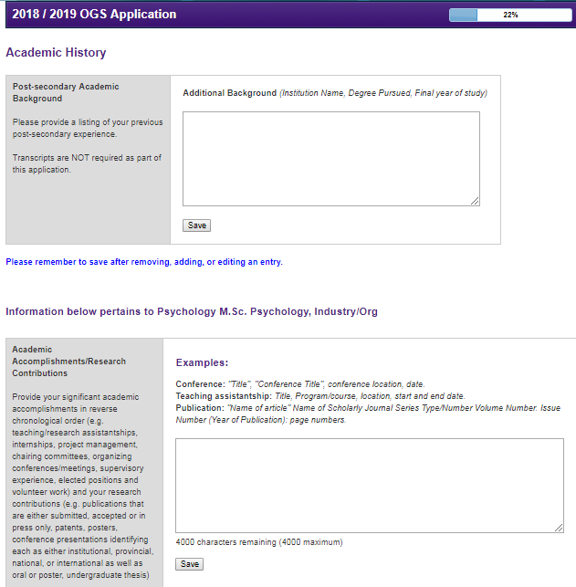
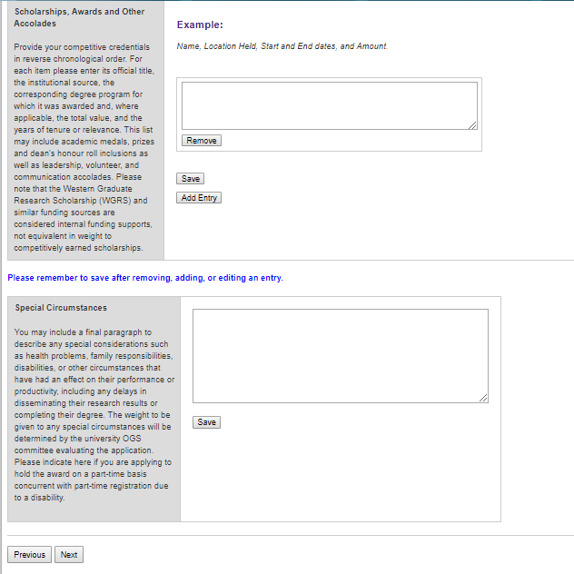

Proposal

Outline of proposed research for both Master’s and Doctoral. Maximum 4,000 character limit.

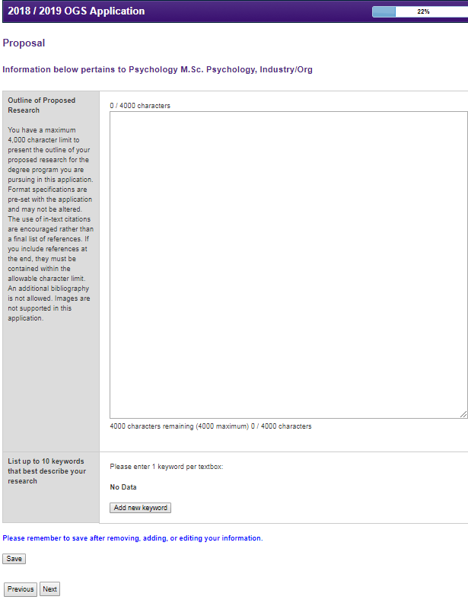

Referees

The applicant is required to identify two academic referees that will complete an academic assessment in support of the application.

The applicant is prompted to send the reference request (via email) to each referee, inviting them to complete a report. Each referee is provided a “requested completion date” which is two weeks from the date the request was initially sent. The referee is also informed that the applicant may not finalize and submit their OGS application if a reference is outstanding.

The applicant will receive an email confirmation when a reference has been completed. The status of the report request will be visible to the student on this page.

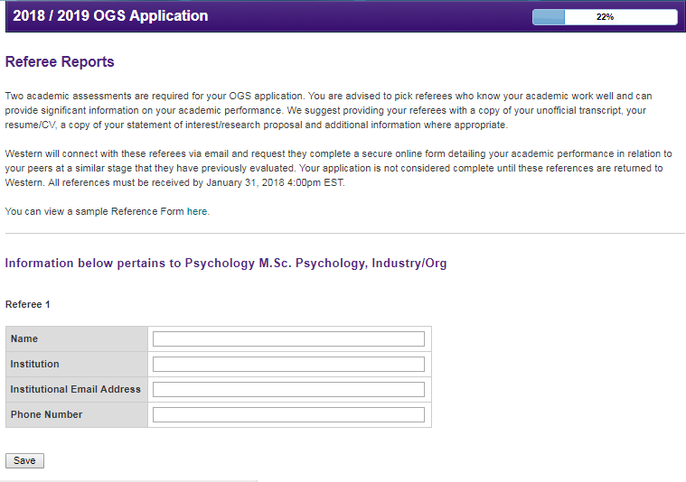
An applicant may change a referee, or update an email address any time prior to the referee submitting their report. Once a report is submitted by a referee, no revisions can be made.
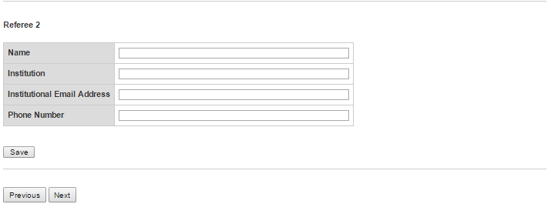

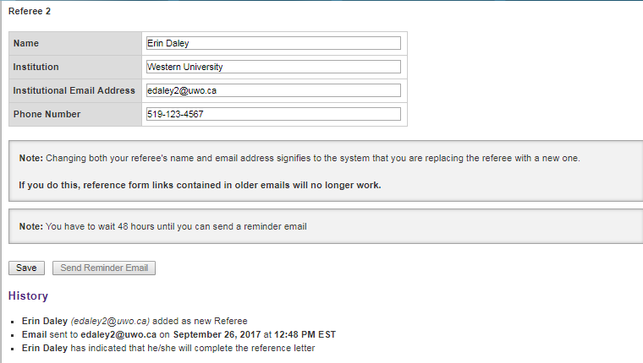

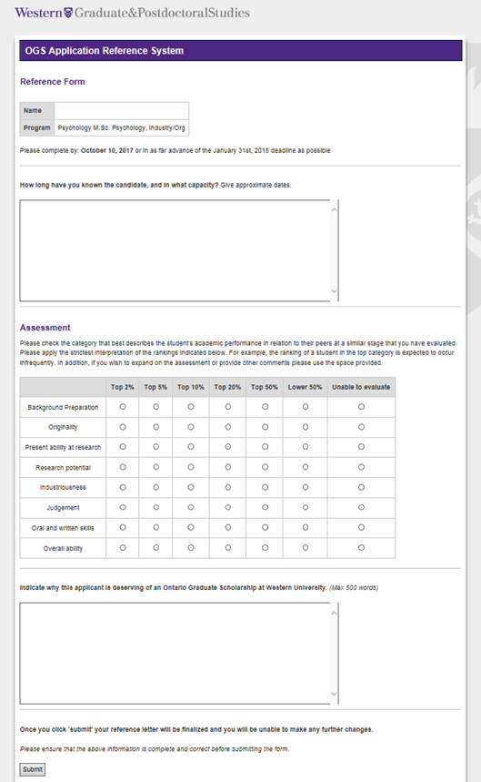

Finalization

Once all components are complete, the applicant is directed to Finalize and Submit the application. The Finalization page requires the applicant’s consent to the FIPPA statement as well as the applicant’s declaration attesting compliance on each item before the application can be finally submitted.

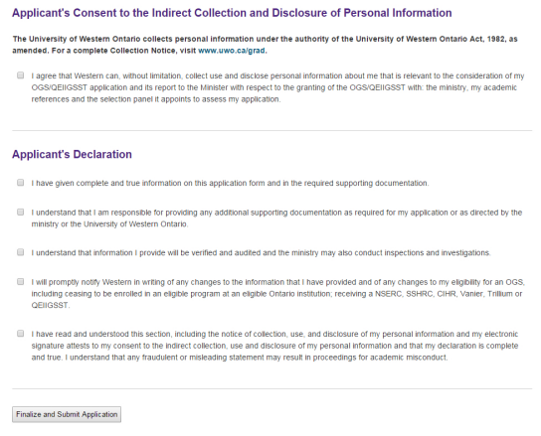

After the application is finalized and submitted, the applicant will be able to view the application but will not have access to modify it in any way. Any applicant who requires access after submission is directed to contact SGPS.

