PROGRESS REPORTING (draft proposal)

SGPS has proposed a standard method to electronically distribute and collect progress reports from all eligible graduate students at Western. The following is a draft proposal on how such a system could work for the graduate community at Western within context of the PeopleSoft Student Center environment.
A review of all current practices around the community was completed in late 2014. SGPS hopes to provide a standardized form and supporting process that accounts for the needs of all graduate programs.

Draft Structure of Progress Report listing (Student side)
Students have access to new service in SGPS Student Portal titled My Progress Reports:
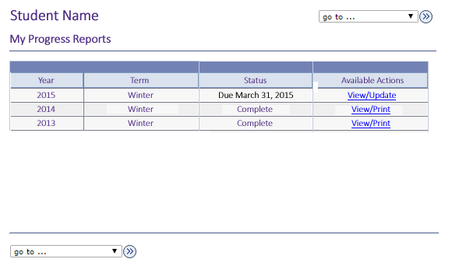
My Progress Reports lists all current and historical progress reports made by student.
Draft Structure of Progress Report – breakdown (Student side)
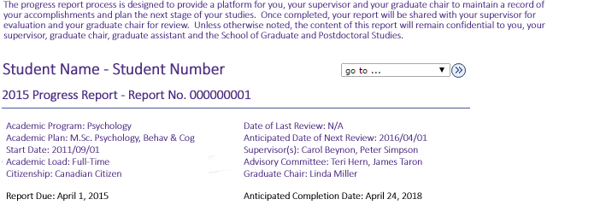
The top of the report provides basic information about the student from existing data in PeopleSoft.
Contact information reviews and confirms existing information in Student Center
Registration Summary provides a step by step history of the student’s admission and registration in their degree program.
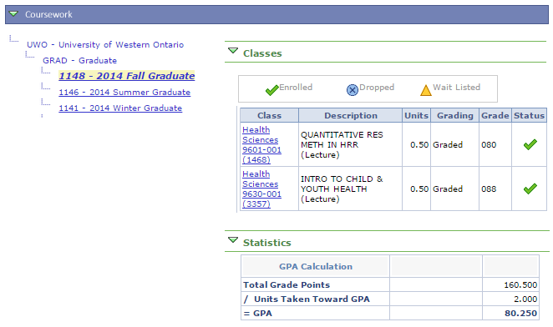
Coursework provides an overview of all coursework in-progress and completed while registered in the degree program as retained in PeopleSoft Student Center.
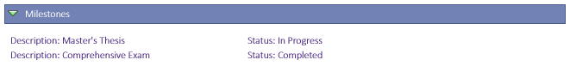
Milestones are non-course related but vital requirements that a student must complete toward degree progress in order to graduate. Each graduate degree may require a pre-determined set of milestones that apply to all students attempting that particular degree. These milestones are applied to a student record at the commencement of their registration. Milestones may appear on academic records and official transcripts. A milestone may have the following levels of completion assigned to it:
- Not completed
- In progress
- Completed
All milestones on a student record must be completed prior to graduation.
Graduate milestones include but are not limited to:
- Comprehensive Examinations or Equivalent
- Seminars
- Language Requirement Examinations
- Placements/Field Work
- Major Paper/Research Project/Thesis Work
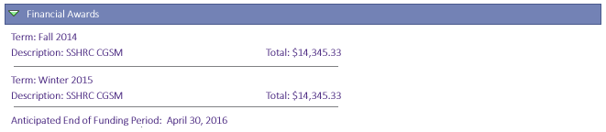
Financial Awards would automatically detail all external scholarship payments paid out to student from Student Center including:
- OGS/QEII/Trillium
- Tri-Council Awards

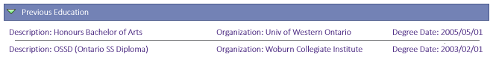
Previous Education details previously attended schools as outlined in the student’s applications to Western.
Western Employment details any job codes held in the Human Resources database over the course of the reporting period.
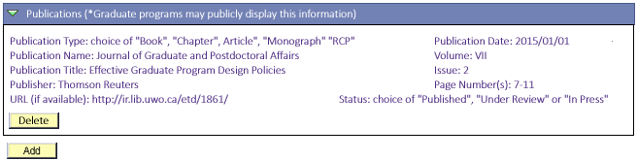
Publications permit the student to insert all works submitted during their degree program. Allow students to connect an ORCID to summarize works. All previous entries will be presented and the student can add/delete new entries as necessary. Publication types can be updated as necessary. Currently set to include:

- Book
- Chapter
- Article
- Monograph
- RCP

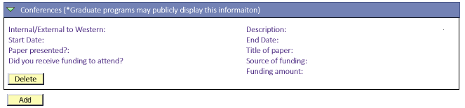
Conferences will collect details on which conferences a student attends, whether the student presents at the conference during their degree program and if any funding was received to attend.
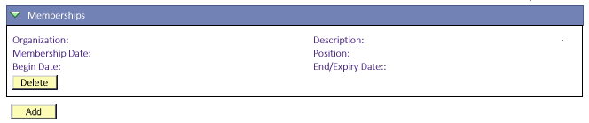
Memberships will collect details on any positions a student holds with external organizations in relation to their studies.
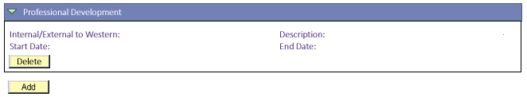
Professional Development will collect details on any training a student receives while completing their degree program.
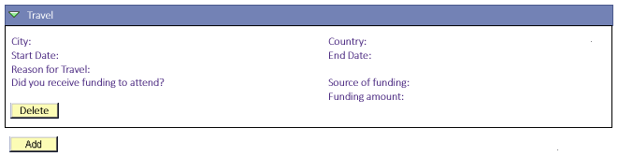
The Travel field collects any travel a student takes while completing their degree program, the reason for that travel and whether any funding was used.
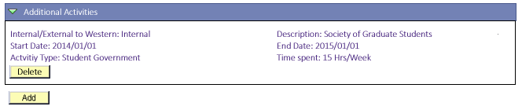
Activities permit the student to provide any relevant information pertaining to their activities outside of the classroom in relation to their studies that are not already recorded as milestones. The activity is noted as being either internal or external to Western. Default activity types could include:

- Seminar participation/presentation
- Performances
- Service
- Student Government

Programs will be able to define which activities should be available to their students beyond these default values. Communications to students within their program will detail how this field should be completed to meet the demands of the program.
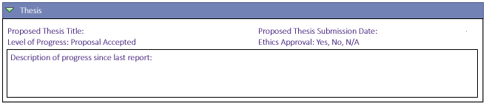
Students participating in a thesis-based program will receive this field to provide an update on the progression of their research/writing.
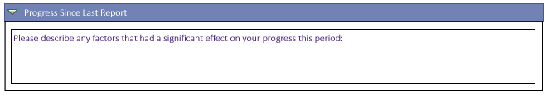
Students can use these fields to describe any positive or negative impacts on their progress since their last report.

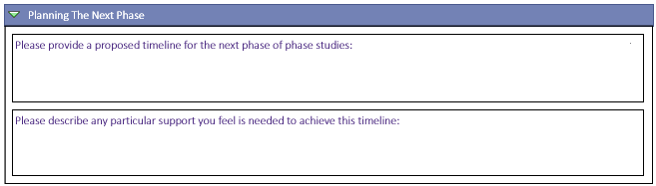
Students will use these fields to outline goals/timelines for the next phase of their studies.

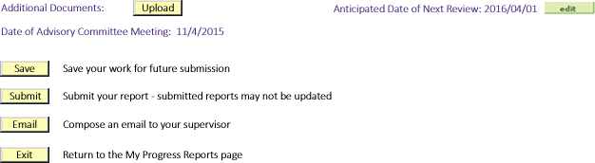
Students may save the work for future submission or submit it. The page also facilitates emails to the student’s supervisor if the need arises.
Draft Structure of Progress Report – breakdown (Supervisor side)
After the student submits the completed report the supervisor(s) (if present) will be notified with an email to complete a review of the submission. Accessing the report will provide a review of all information submitted by the student followed by the following Evaluation field:
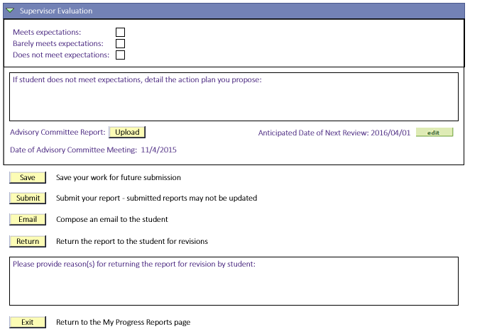

Draft Structure of Progress Report – breakdown (Graduate Chair side)
After the supervisor(s) submits the completed Evaluation the Graduate Chair will be notified with an email to complete a review of the submission. Accessing the report in Student Center will provide a review of all information submitted by the student and supervisor followed by the following Evaluation field:
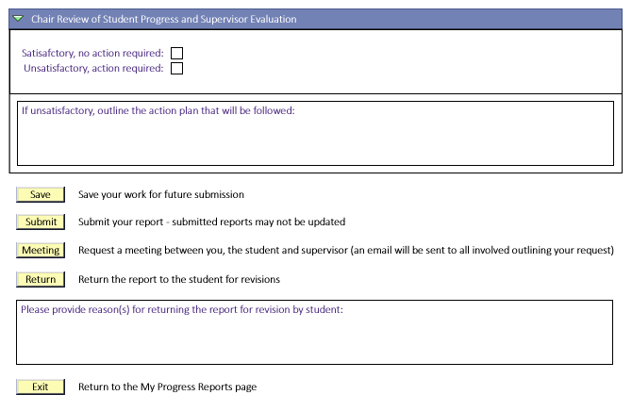

Draft Structure of Progress Report – breakdown (Student review side)
After the Graduate Chair submits the completed Review the student will be notified with an email to complete review of the submission. Accessing the report will provide a review of all information submitted by the student, supervisor and chair followed by the following acknowledgement field:
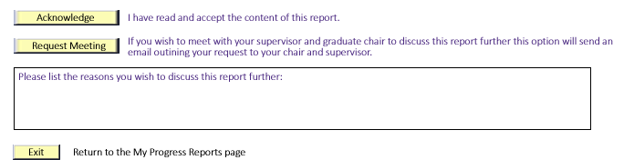
After Acknowledgment is received the report is now considered Complete and is archived in the My Progress Reports component for future reference.

